Lab 18: Simple EXE Hacking with Immunity
Course Name: Malware Analysis and Reverse Engineering (IAM302)
Student Name: Nguyễn Trần Vinh – SE160258
Instructor Name: Mai Hoàng Đỉnh
Lab Due Date: 22/3/2023

What You Need
A Windows machine, real or virtual. I used a Windows Server 2008 virtual machine.

Purpose
To modify a Windows EXE file and save an altered version. This gives you practice with very simple features of the Immunity debugger.

Task 1: Target EXE Recon
Get Immunity
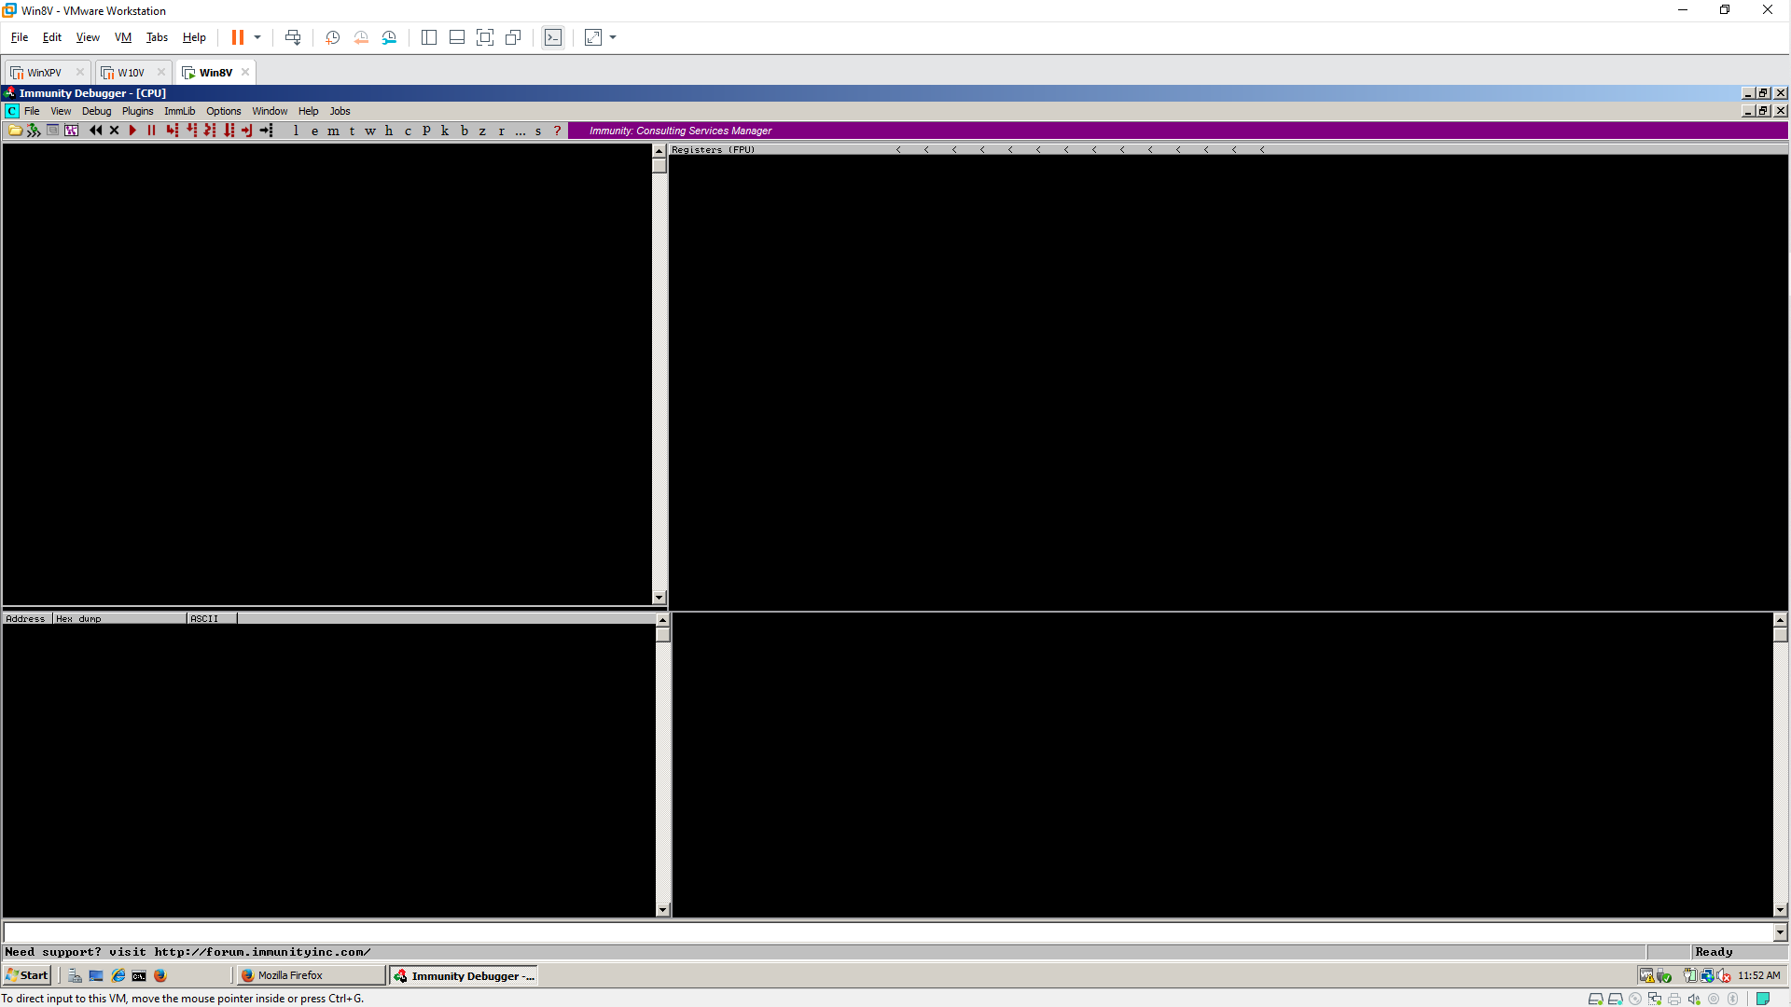

Get putty.exe
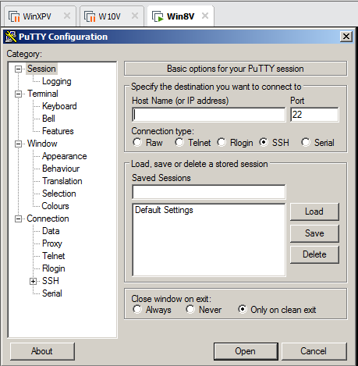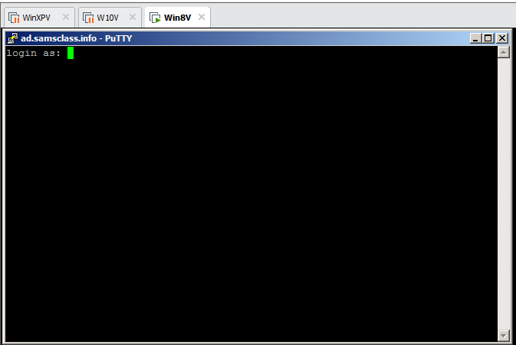

Starting the Immunity Debugger
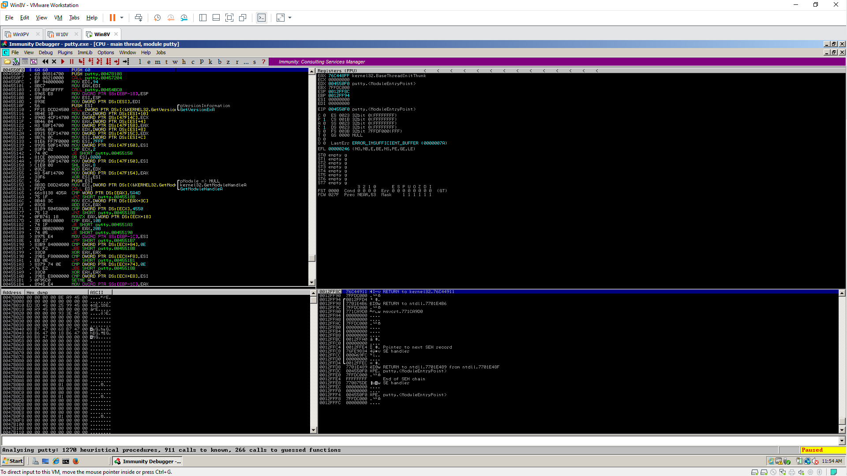

Running Putty in Immunity
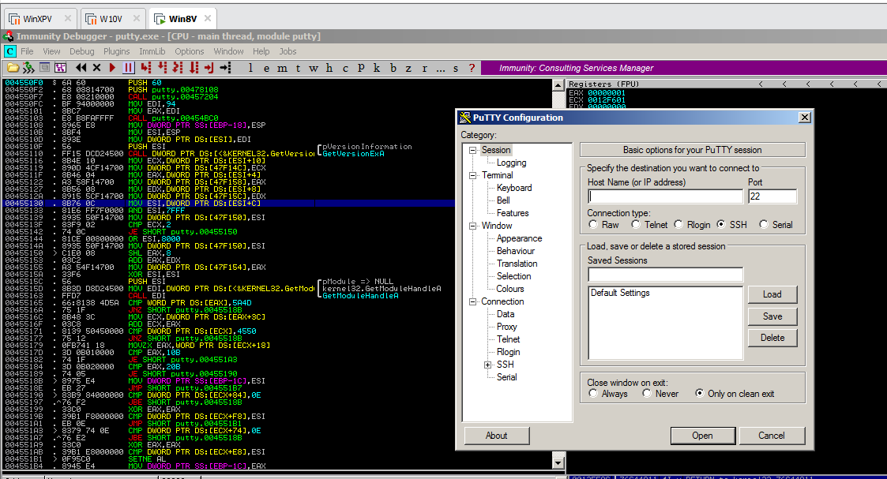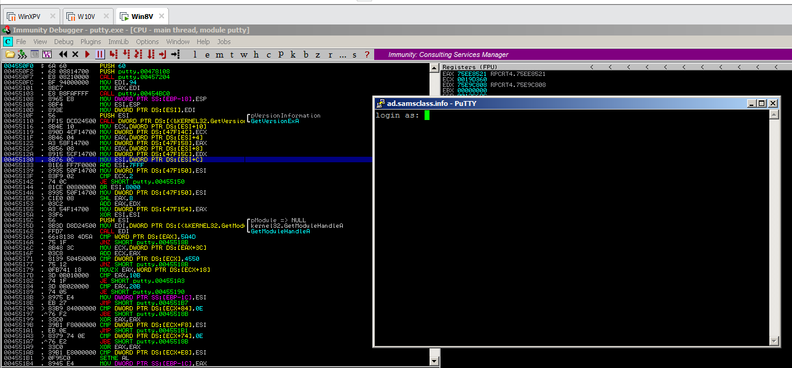

Finding the "login as" Code
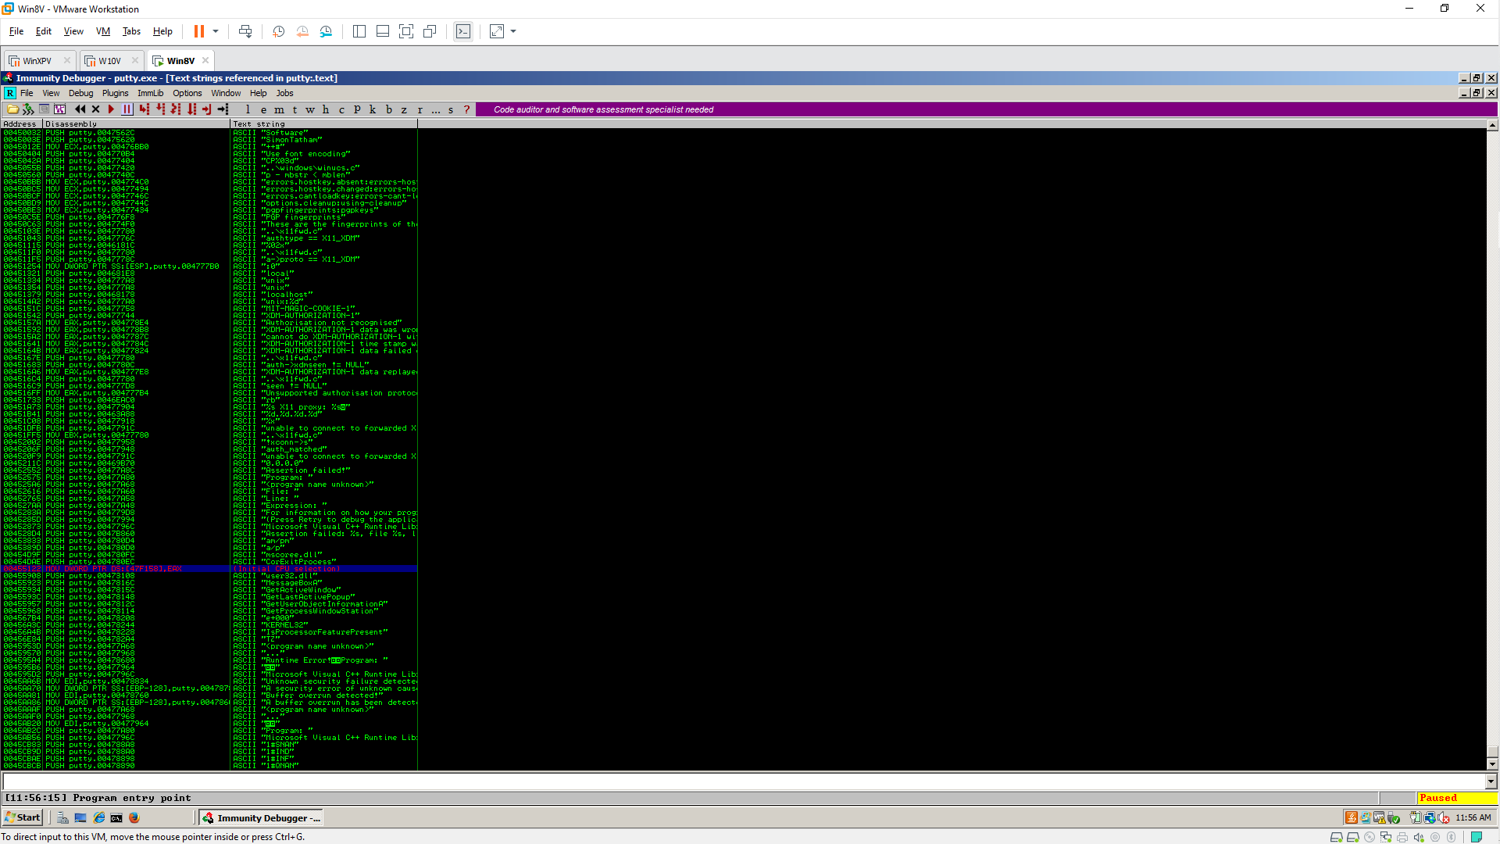
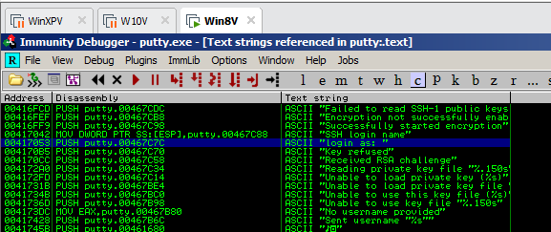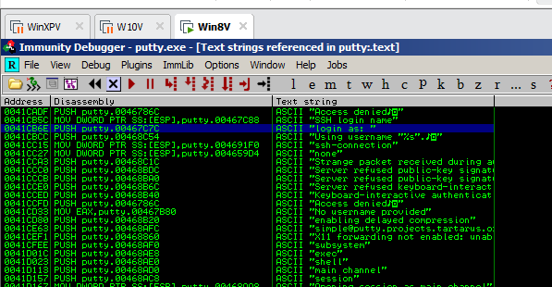

Using Breakpoints
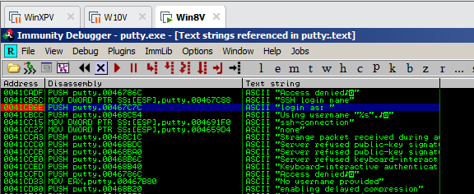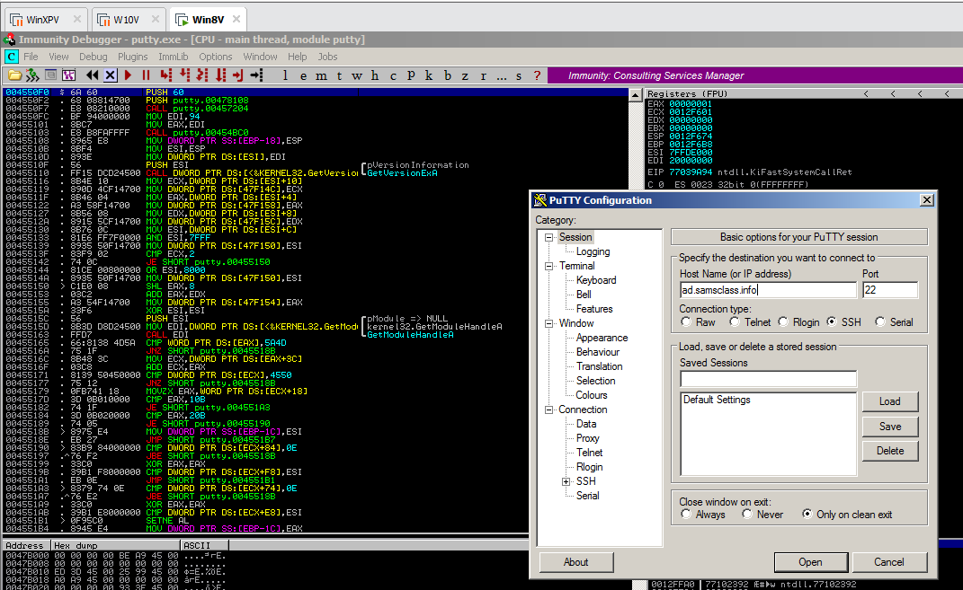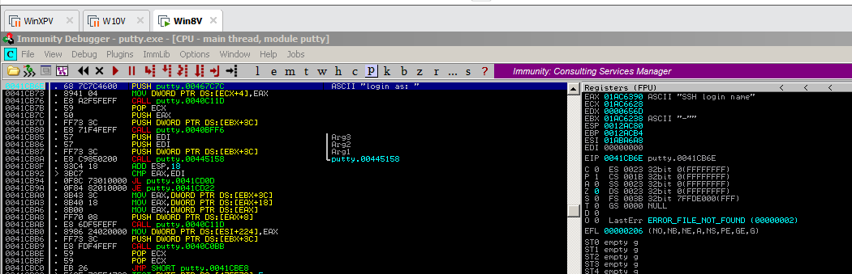

Task 2: Alter the Login Message
Removing the Breakpoint
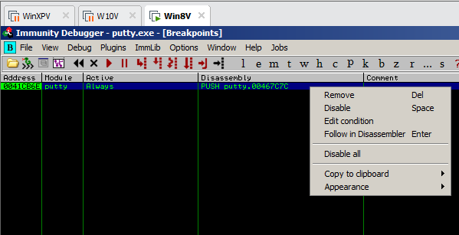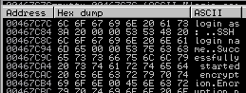

Skipping the First Letter In the Message
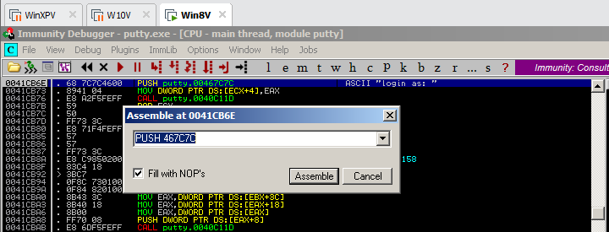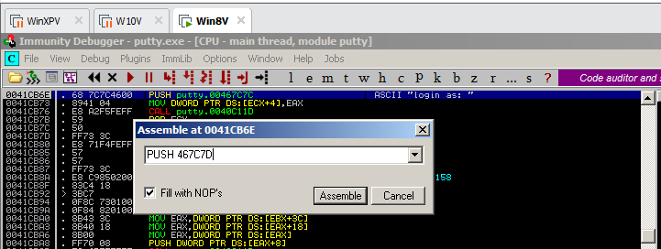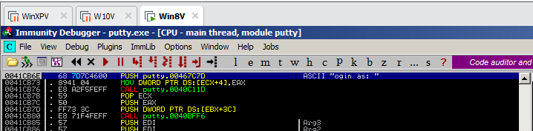
Running the Modified Program
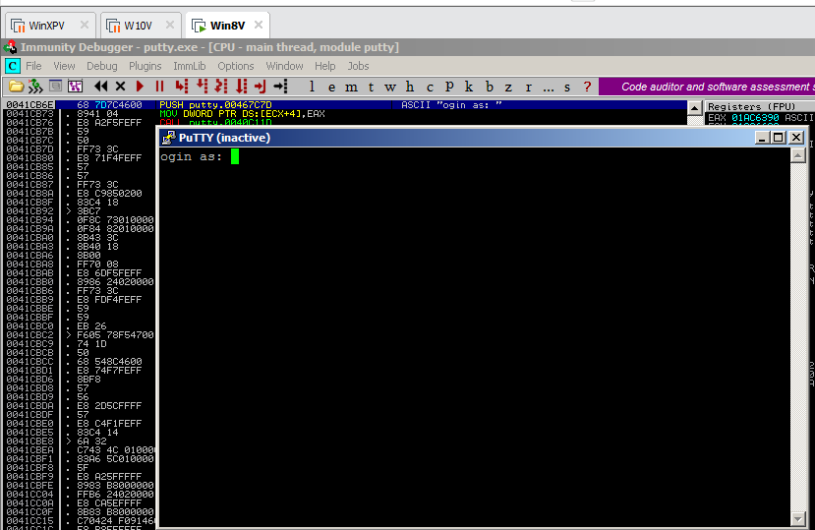

Inserting Your Name
